2. RNA Analysis (mRNA Features)

The DNA sequence identified in the previous analysis was first converted into its corresponding mRNA sequence using an online transcription tool. RNA-level analysis was then performed to investigate untranslated regions (UTRs), secondary structure, and regulatory sequence motifs.
The mRNA secondary structure was predicted using RNAfold from the ViennaRNA Webserver. RNAfold computes the minimum free energy (MFE) structure, representing the most thermodynamically stable folding of the RNA molecule.
The graphical output displays stem–loop structures and branching regions. Color coding represents base-pairing probabilities, where red regions indicate highly stable base pairs and blue regions represent less stable or unpaired nucleotides.
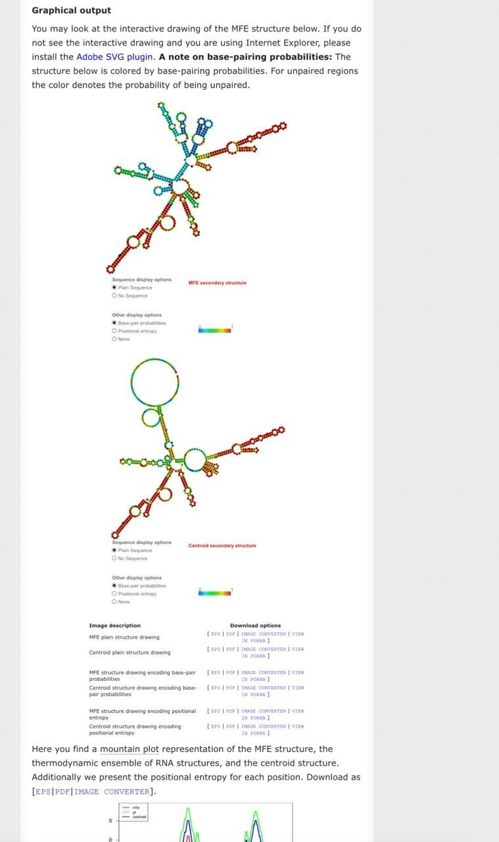
RNA Structure Stability Explanation:
  - The presence of multiple stem–loop structures indicates stable intramolecular base pairing.
  - Low free energy folding suggests that the mRNA structure is thermodynamically stable.
  - Stable secondary structures can influence ribosome binding and translation efficiency.

Identification of regulatory elements
The mRNA sequence was analyzed for known regulatory elements such as the Kozak consensus sequence and polyadenylation (polyA) signals. As expected for a bacterial plasmid-derived gene, a canonical eukaryotic Kozak sequence and polyA signal were not detected.
However, the sequence contains a clear start codon (AUG) positioned appropriately for translation initiation, confirming that the mRNA is competent for protein synthesis in a prokaryotic system.
